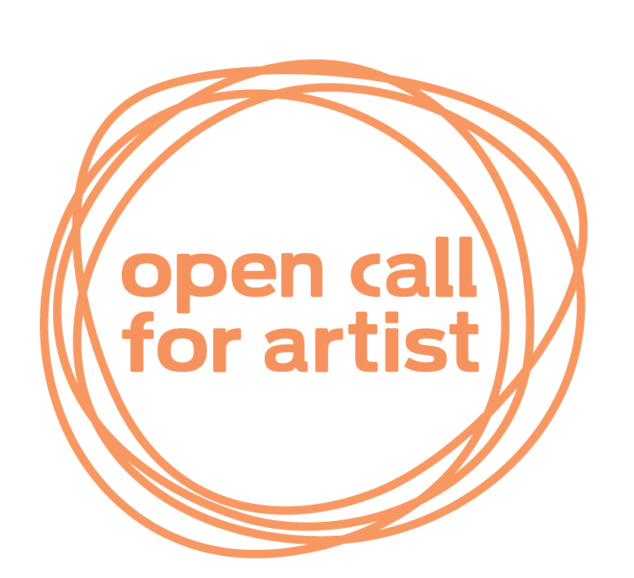
This is an Open Call Form for Artists. This form will be held on file for a year after its entry date. It will be referenced for all exhibitions with the exception of SMart Festival and ArtPrize. This is for a solo or group show.

APPLICATION FORM

FIRST NAME: ________________________ LAST NAME: ______________________

EMAIL ADDRESS: _________________________________________________

MAILING ADDRESS: __________________________________________________________

CITY: ________________________ STATE: __________ZIP: _________________

COUNTRY: ____________________________ PHONE*:_____________________________

*PLEASE INCLUDE COUNTRY CODE IF OUTSIDE U.S
CATEGORIES:

VIDEO/FILM:
- EXPERIMENTAL/ART
- NON-FICTION/DOCUMENTARY
- FICTION/NARRATIVE
- ANIMATION

OTHER MEDIUMS:

- DIGITAL PHOTOGRAPHY
- VIDEO PROJECTION
- ELECTRONIC MUSIC
- INTERACTIVE ART, WEBSITE, GRAPHIC DESIGN
- THEORETICAL WORK IN MULTIMEDIA ART
- VIDEO INSTALLATION
- PERFORMANCE ART
- EXPERIMENTAL MUSIC
- OTHER (please specify) _____________________________

Please include the following information with this application:

- Resume/ Brief Biography

- Artist Statement

- 5-15 images on a CD in JPEG format at 300 ppi. Please include title, medium, and dimensions. *
*Although every precaution is taken, the gallery is not responsible for any loss of or damage to material sent in for gallery review. Do not send original artwork for the portfolio submission. If you are sending material you would like returned, please include a self-addressed stamped envelope with this application.*

If you would like to apply for a solo show it is recommended to have more than 10 images as examples of work.

SUBMISSION FORMATS FOR VIDEO ART: MINI-DV, DV-CAM, DVD, AND CD-ROM

A $10.00 submission fee is applied to each entry.
A $5.00 submission fee is applied for students with a copy of a current student ID.

Please make all checks payable to Open Concept Gallery.

- MasterCard
- Visa
- Credit Card # _______________________
Exp. Date____________________

Signature_________________________________________________

DEADLINE: Ongoing

All selected applicants will be notified via email or phone by the curatorial team.

